Four pillars: Inheritance, Polymorphism, Abstraction, Encapsulation

Introduction to the Four Pillars of OOP in Java
Object-Oriented Programming (OOP) in Java revolves around four core principles—often called pillars—that promote code reusability, modularity, and maintainability. These are Inheritance, Polymorphism, Abstraction, and Encapsulation. Below, I'll break each down in simple terms, with a concise Java example.

1. Inheritance
Simple Explanation: Inheritance lets one class (child/subclass) acquire properties and methods from another class (parent/superclass), like a child inheriting traits from a parent. It promotes "is-a" relationships and code reuse without duplication.
Key Benefits: Reduces redundancy; allows overriding for customization.
Java Example:
// Parent class
class Animal {
void eat() {
System.out.println("This animal eats food.");
}
}

// Child class inheriting from Animal
class Dog extends Animal {
void bark() {
System.out.println("The dog barks.");
}
}

public class Main {
public static void main(String[] args) {
Dog dog = new Dog();
dog.eat(); // Inherited method
dog.bark(); // Own method
}
}
// Output: This animal eats food. \n The dog barks.

2. Polymorphism
Simple Explanation: Polymorphism means "many forms"—it allows objects of different classes to be treated as instances of the same class through a common interface. It enables method overriding (runtime) or overloading (compile-time), so the right version runs based on the object.
Key Benefits: Flexibility; one interface, multiple implementations.
Java Example (Method Overriding for Runtime Polymorphism):
// Parent class
class Shape {
void draw() {
System.out.println("Drawing a shape.");
}
}

// Child classes
class Circle extends Shape {
@Override
void draw() {
System.out.println("Drawing a circle.");
}
}

class Square extends Shape {
@Override
void draw() {
System.out.println("Drawing a square.");
}
}

public class Main {
public static void main(String[] args) {
Shape myShape = new Circle(); // Upcasting
myShape.draw(); // Calls Circle's version
myShape = new Square();
myShape.draw(); // Calls Square's version
}
}
// Output: Drawing a circle. \n Drawing a square.

3. Abstraction
Simple Explanation: Abstraction hides complex implementation details and shows only essential features, like using a TV remote without knowing its internal wiring. In Java, it's achieved via abstract classes or interfaces, forcing subclasses to provide specifics.
Key Benefits: Simplifies code; focuses on "what" not "how"; enhances security by hiding internals.
Java Example (Using Abstract Class):
// Abstract class
abstract class Vehicle {
abstract void start(); // Must be implemented by subclasses

void stop() { // Concrete method – introduced in java 8
System.out.println("Vehicle stopped.");
}
}

// Concrete subclass
class Car extends Vehicle {
@Override
void start() {
System.out.println("Car engine started.");
}
}

public class Main {
public static void main(String[] args) {
Car myCar = new Car();
myCar.start(); // Abstract method implemented
myCar.stop(); // Inherited concrete method
}
}
// Output: Car engine started. \n Vehicle stopped.

4. Encapsulation
Simple Explanation: Encapsulation bundles data (variables) and methods that operate on it into a single unit (class), then restricts direct access using access modifiers (private, protected). It's like a capsule protecting its contents—access only through controlled methods (getters/setters).
Key Benefits: Data protection; easier maintenance; prevents invalid states.
Java Example:
class BankAccount {
private double balance; // Private data (encapsulated)

// Getter
public double getBalance() {
return balance;
}

// Setter with validation
public void deposit(double amount) {
if (amount > 0) {
balance += amount;
} else {
System.out.println("Invalid deposit amount.");
}
}
}

public class Main {
public static void main(String[] args) {
BankAccount account = new BankAccount();
account.deposit(100.0);
System.out.println("Balance: " + account.getBalance());
// account.balance = -50; // Error: private access denied
}
}
// Output: Balance: 100.0

These pillars work together:
Inheritance sets the base for Polymorphism, Abstraction builds on it, and Encapsulation secures everything

Classes and objects: Creation, methods, and instance vs. static members

Simple Explanation:
A class is a blueprint or template that defines the structure and behavior for objects—like a cookie cutter. An object is an actual instance created from that class, with its own data—like a baked cookie. Classes group related data (fields) and actions (methods); objects bring them to life.
Key Benefits: Organizes code; models real-world entities (e.g., a Car class for multiple car objects).

Java Example (Basic Class Definition and Object Creation):
// Class definition (blueprint)
class Car {
String model; // Field (data)
}

// Creating an object (instance)
public class Main {
public static void main(String[] args) {
Car myCar = new Car(); // Object creation using 'new'
myCar.model = "Toyota"; // Accessing field
System.out.println(myCar.model);
}
}
// Output: Toyota

Creation of Classes and Objects
Simple Explanation: Create a class by declaring it with class keyword and curly braces for its contents. Create objects with the new keyword followed by the constructor call—this allocates memory and initializes the object.
Key Points: Constructors (special methods) initialize objects; default if none provided.
Java Example (With Constructor):
class Car {
String model;

// Constructor for initialization
public Car(String model) {
this.model = model; // 'this' refers to current object
}
}

public class Main {
public static void main(String[] args) {
Car myCar = new Car("Honda"); // Creation with args
System.out.println(myCar.model);
}
}
// Output: Honda

Methods in Classes
Simple Explanation: Methods are functions defined inside a class that perform actions on objects or classes. They can take parameters, return values, and use access modifiers (e.g., public). Called on objects (instance methods) or directly on the class (static methods).
Key Benefits: Encapsulate behavior; promote reusability.
Java Example (Instance and Static Methods):
class Car {
String model;

public Car(String model) {
this.model = model;
}

// Instance method (needs object to call)
public void drive() {
System.out.println(model + " is driving.");
}

// Static method (belongs to class)
public static void honk() {
System.out.println("All cars honk!");
}
}

public class Main {
public static void main(String[] args) {
Car myCar = new Car("Ford");
myCar.drive(); // Call on object
Car.honk(); // Call on class
}
}
// Output: Ford is driving. \n All cars honk!

Instance vs. Static Members
Key Differences:
Aspect | Instance Members | Static Members
Belongs To | Object (unique per instance) | Class (shared by all instances)
Access | Via object (e.g., obj.field) | Via class (e.g., Class.method)
Memory | Created on new; multiple copies | Created once on class load
Use Case | Object-specific data/behavior | Shared utilities/constants

Java Example:
class Car {
String model; // Instance field (per car)
static int totalCars = 0; // Static field (shared count)

public Car(String model) {
this.model = model;
totalCars++; // Shared counter increments
}

// Instance method
public void display() {
System.out.println("Model: " + model);
}

// Static method
public static void showTotal() {
System.out.println("Total cars created: " + totalCars);
}
}

public class Main {
public static void main(String[] args) {
Car car1 = new Car("BMW");
Car car2 = new Car("Audi");

car1.display(); // BMW (unique to car1)
car2.display(); // Audi (unique to car2)
Car.showTotal(); // 2 (shared)
}
}
// Output: Model: BMW \n Model: Audi \n Total cars created: 2

Constructors: Default, parameterized, copy, and constructor overloading/chaining

Simple Explanation: Constructors are special methods in a class that initialize objects when created with new. They have the same name as the class, no return type, and run automatically. They set initial values for fields, ensuring objects start in a valid state. Java provides a default one if none defined.
Key Benefits: Enforce initialization; prevent uninitialized objects; customizable via parameters.

1. Default Constructor
Simple Explanation: A no-argument constructor provided automatically by Java if no others exist. It initializes fields to default values (e.g., 0 for int, null for objects). You can define your own for custom defaults.
Key Points: Implicit if absent; calls super() for inheritance.
Java Example:
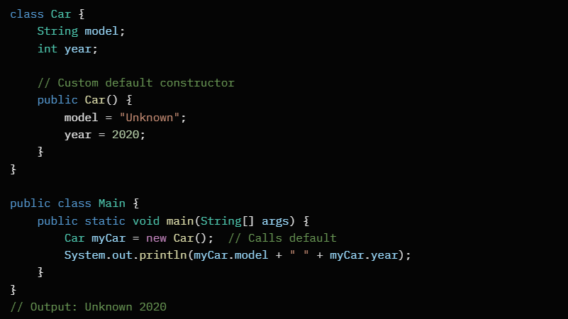

2. Parameterized Constructor
Simple Explanation: Takes arguments to initialize fields with specific values passed during object creation. Useful for flexibility—create objects with predefined data.
Key Points: Must be called with matching arguments; no default if only this exists.
Java Example:
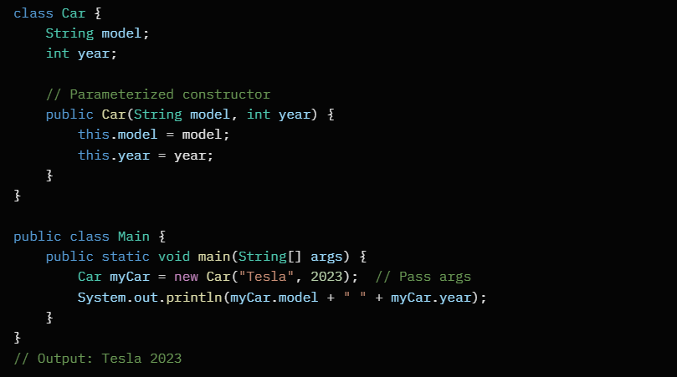

3. Copy Constructor
Simple Explanation: A parameterized constructor that takes another object of the same class and copies its field values. Creates a "clone" with the same state—handy for duplicating objects without deep copies (beware of references).
Key Points: Not built-in; manual implementation; use this to avoid confusion with fields.
Java Example:
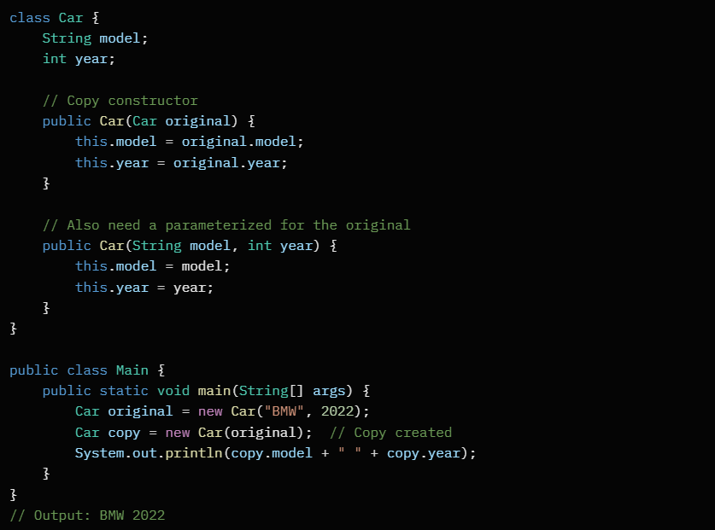

4. Constructor Overloading
Simple Explanation: Multiple constructors in the same class with different parameter lists (number, type, order). Java picks the matching one at compile-time, like method overloading but for init.
Key Benefits: Provides options (e.g., default vs. full params) without extra methods.
Java Example (Combines default and parameterized):
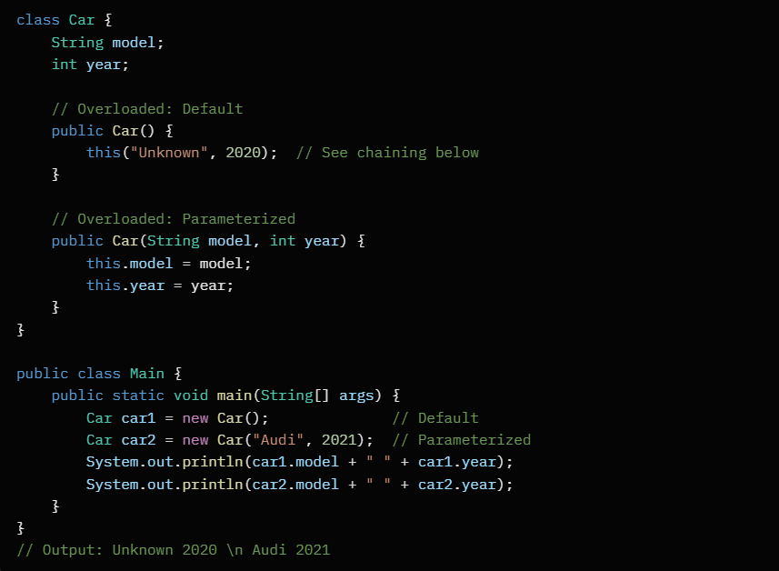

5. Constructor Chaining
Simple Explanation: One constructor calls another in the same class using this() (must be first line) to reuse code and avoid duplication. Also chains to parent via super() for inheritance.
Key Points: Prevents redundancy; this() for same class, super() for superclass; error if omitted in subclasses.
Java Example (From overloading above; explicit chaining):
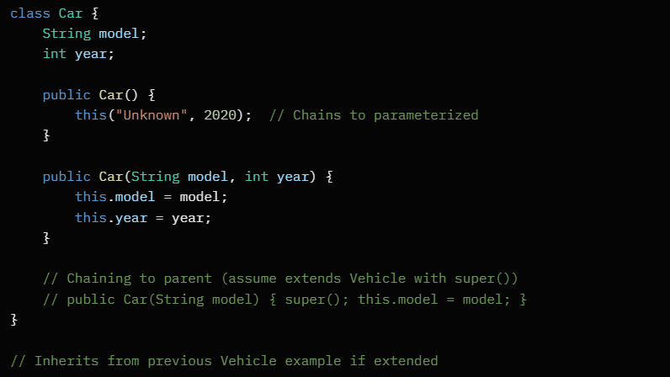

Comparison of Constructor Types
Type | Args | Purpose | Auto-Provided?
Default | None | Basic init with defaults | Yes (if none)
Parameterized | Specific | Custom init with values | No
Copy | Existing obj | Duplicate object state | No
Overloading | Varies | Multiple init options | N/A
Chaining | Via this/super | Reuse code across constructors | N/A

For interviews:
Explain why no return type (implicit this), private constructors (singleton pattern), or exceptions in constructors. Code a full class with all types and discuss this vs. field naming conflicts!

Inheritance: Types (single, multilevel, hierarchical), IS-A relationship, and limitations (no multiple inheritance for classes)

Simple Explanation: Inheritance allows a class (subclass) to inherit fields and methods from another class (superclass) using extends, promoting code reuse and "is-a" hierarchies (e.g., a Dog is-a Animal). Subclasses can override methods for specialization.
Key Benefits: Reduces duplication; supports polymorphism.

IS-A Relationship
Simple Explanation: Represents a hierarchical "is-a" link—e.g., "Car is-a Vehicle" or "Sparrow is-a Bird is-a Animal." It defines specialization: subclass shares superclass traits but adds/refines its own. Tested via instanceof operator.
Java Example:
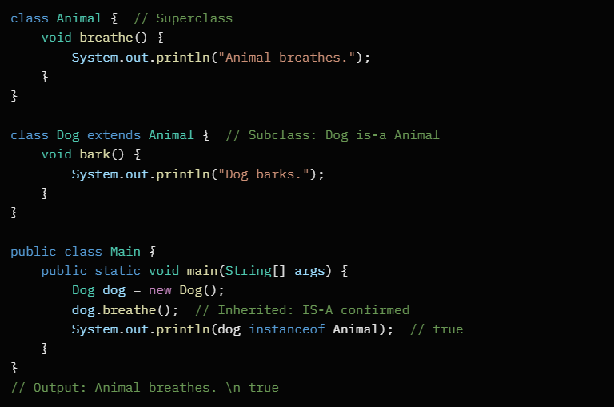

Types of Inheritance
Java supports three main types via classes (interfaces add more, like multiple). Below are examples using a base Animal hierarchy.

1. Single Inheritance
Simple Explanation: One subclass inherits from one superclass—like a direct parent-child link. Most common; simple chain.
Java Example:
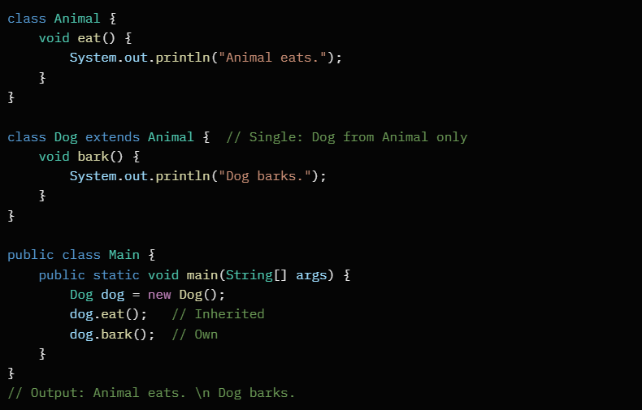

2. Multilevel Inheritance
Simple Explanation: Chain of inheritance—subclass inherits from a subclass, forming levels (e.g., Grandparent > Parent > Child). Like a family tree line.
Java Example:
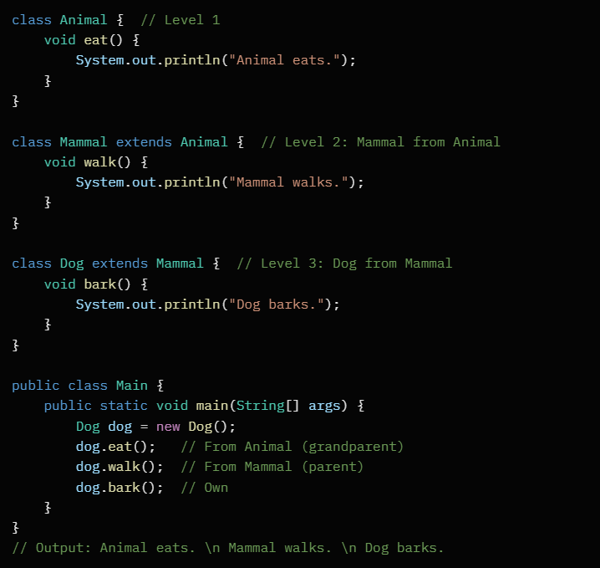

3. Hierarchical Inheritance
Simple Explanation: Multiple subclasses inherit from one superclass—like branches from a tree root. Shared base behavior across siblings.
Java Example:
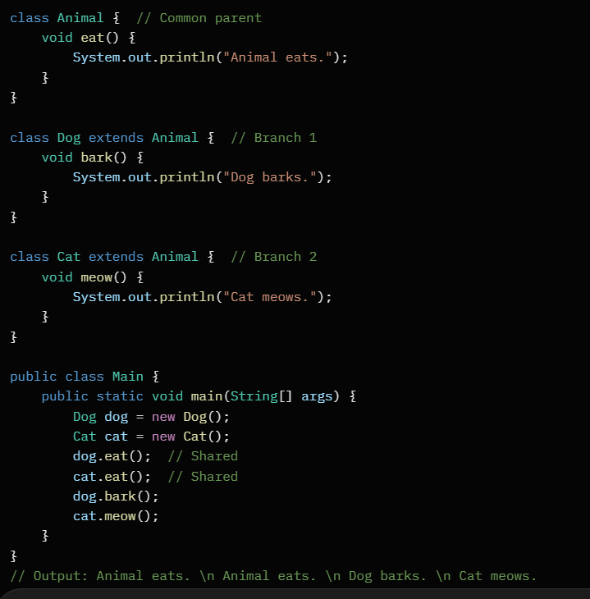

Comparison of Types
Type | Structure | Example Use Case | Supported in Java Classes?
Single | One parent, one child | Basic specialization (Dog > Animal) | Yes
Multilevel | Chain (A > B > C) | Deep hierarchies (Vehicle > Car > SUV) | Yes
Hierarchical | One parent, many children | Shared base (Animal > Dog/Cat) | Yes

Limitations
Simple Explanation: Java classes don't support multiple inheritance (a class extending two+ superclasses) to avoid ambiguity like the "diamond problem" (conflicting methods from two parents). Workaround:
Use interfaces (a class can implement many) for multiple behaviors. Also, no cyclic inheritance (A > B > A) to prevent infinite loops.

Java Example (Diamond Problem—Why Avoided):
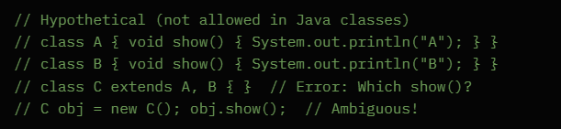

Workaround with Interfaces:
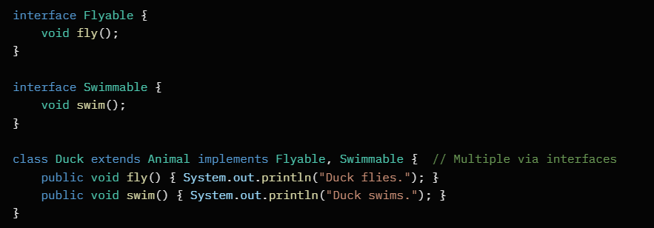

For interviews:
Sketch diagrams for types (arrows for extends), explain super() for parent access, and contrast with C++ (which allows multiple but risky).
Common Q: "How to achieve multiple inheritance? (Interfaces!)"

Polymorphism: Compile-time (method overloading) vs. runtime (method overriding, dynamic method dispatch)

Simple Explanation: Polymorphism ("many forms") lets objects of different types respond to the same method call in varied ways, enabling flexible code. It splits into compile-time (decided by compiler, based on code) and runtime (decided by JVM at execution, based on object type).
Key Benefits: Interchangeable objects; easier extension without changing clients.

Compile-Time Polymorphism (Method Overloading)
Simple Explanation: Resolved during compilation—compiler picks the method based on arguments (number, type, order). Same method name, different signatures. Static; no object type involved.
Key Points: Happens in same class or inheritance; promotes multiple ways to call one name.
Java Example:
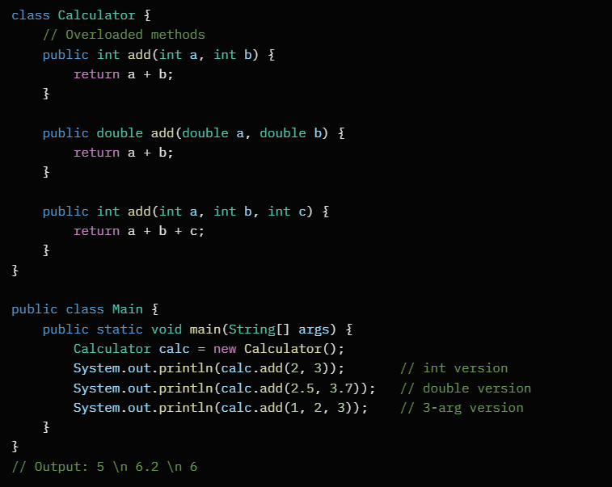

Runtime Polymorphism (Method Overriding & Dynamic Method Dispatch)
Simple Explanation: Resolved at runtime—JVM uses the actual object type to call the correct overridden method. Involves inheritance; parent reference can point to child object.
Method Overriding: Subclass redefines superclass method with same signature.
Dynamic Method Dispatch: JVM's mechanism—binds call to overriding method based on runtime object type (virtual table lookup).
Key Points: Supports "is-a" flexibility; @Override annotation recommended.
Java Example (Overriding with Dispatch):
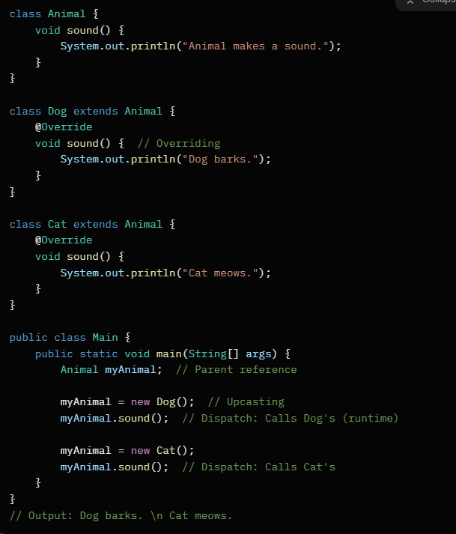

Comparison: Compile-Time vs. Runtime Polymorphism
Aspect | Compile-Time (Overloading) | Runtime (Overriding + Dispatch)
Resolution | Compiler (static binding) | JVM (dynamic binding)
Mechanism | Different signatures | Same signature, different classes
Inheritance | Optional (same class OK) | Required (subclass extends)
Flexibility | Based on args | Based on object type
Performance | Faster (compile-decided) | Slower (runtime lookup)
Use Case | Multiple input handling (e.g., add) | Behavioral variation (e.g., sounds)
Abstraction: Abstract classes and methods vs. interfaces (including default and static methods in interfaces from Java 8)

Simple Explanation: Abstraction hides complex details and exposes only necessary features, like driving a car without knowing engine mechanics. In Java, it's implemented via abstract classes (partial abstraction with some implementation) or interfaces (full abstraction as contracts). Both enforce "what" to do, not "how."
Key Benefits: Reduces complexity; promotes loose coupling; enables polymorphism.

Abstract Classes and Methods
Simple Explanation: An abstract class (declared with abstract) can't be instantiated directly—it's a partial blueprint. It can mix abstract methods (no body; subclasses must implement) and concrete methods/fields. Used for shared code in hierarchies.
Abstract Methods: Declared abstract void method();—forces subclasses to provide implementation.
Key Points: Single inheritance; supports constructors; can have non-abstract elements.
Java Example:
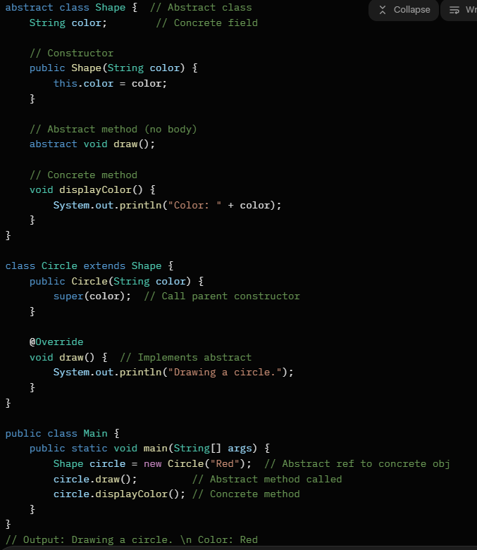

Interfaces
Simple Explanation: An interface (declared with interface) is a 100% abstract contract—defines methods subclasses must implement.
Pre-Java 8: All methods abstract, only constants.
From Java 8: Added default methods (with body, for evolution without breaking code) and static methods (utility, called on interface itself). Supports multiple inheritance.
Key Points: No constructors/fields (except public static final); implemented with implements; default/static enhance flexibility.

Java Example (Including Java 8 Features):
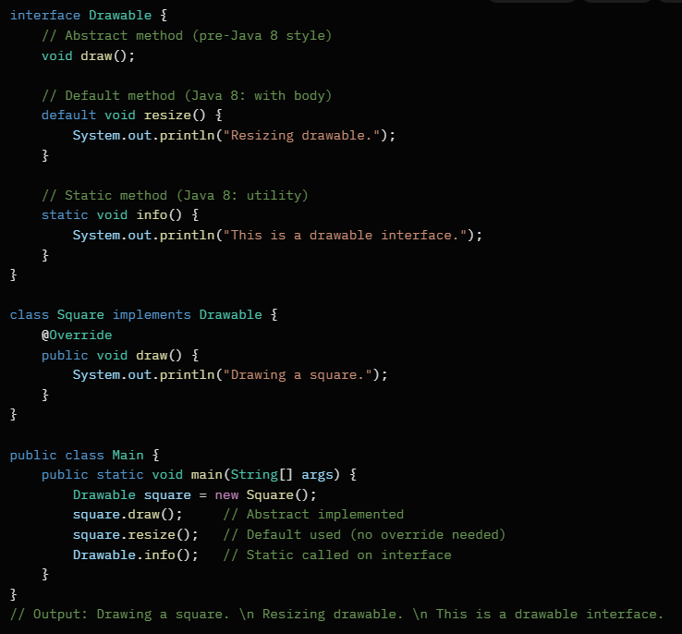

Abstract Classes vs. Interfaces
Aspect | Abstract Classes | Interfaces
Declaration | abstract class | interface
Inheritance | Single (extends) | Multiple (implements)
Methods | Abstract + concrete; no default/static | Abstract (default) + default/static (Java 8+)
Fields | Any (instance/static) | Only constants (public static final)
Constructors | Yes | No
Instantiation | No (but subclasses yes) | No
Use Case | Shared code in hierarchy (e.g., Animal) | Contracts/behaviors (e.g., Flyable)
Java 8+ Enhancements | None specific | Default (backward-compatible evolution), Static (utilities)

Encapsulation: Data hiding, getters/setters, and advantages like flexibility and reusability

Simple Explanation: Encapsulation bundles data (fields) and methods into a class, then hides internal details using access modifiers (e.g., private). It controls access like a vault—external code interacts only through public methods, protecting data integrity.
Key Benefits: Secures data; simplifies maintenance; enables internal changes without breaking clients.

Data Hiding
Simple Explanation: Restricts direct access to class fields by making them private, preventing unauthorized or invalid modifications. External code can't touch internals directly, reducing errors and exposing only what's safe.
Key Points: Uses modifiers (private for hiding, public for exposure); promotes "black box" design.

Java Example (Basic Hiding):
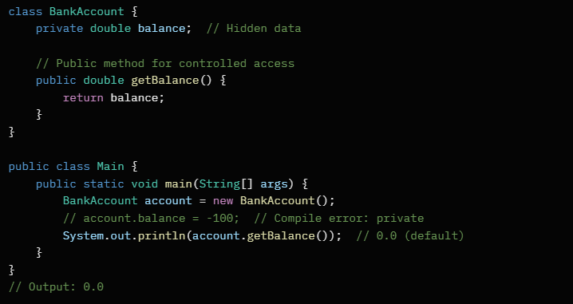

Getters and Setters
Simple Explanation: Getters (accessor methods) retrieve private data safely. Setters (mutator methods) update data with validation logic(optional). Both are public, providing controlled entry points—e.g., setter checks for positive values.
Key Points: Follow naming: getFieldName() / setFieldName(value); can add logic (e.g., bounds checking); JavaBeans convention.
Java Example (With Validation):
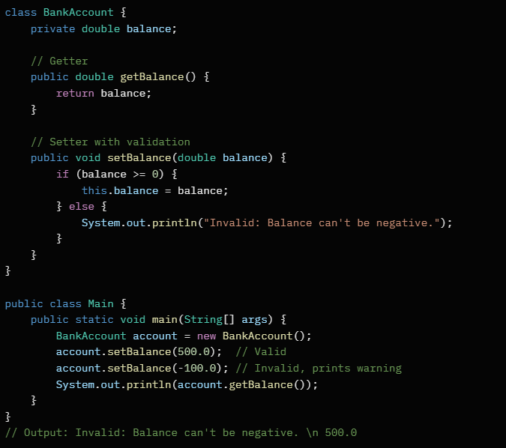

Advantages
Encapsulation boosts code quality by isolating changes and enforcing rules. Key ones include flexibility (easy updates) and reusability (modular classes).
Advantage | Description | Example Impact
Data Protection | Prevents invalid data via hiding/validation | Avoids bugs like negative balances
Flexibility | Internal changes (e.g., field type) don't affect users if getters/setters unchanged | Refactor storage without API breaks
Reusability | Self-contained classes can be used anywhere | BankAccount reusable in apps/banks
Maintainability | Easier debugging/fixing (localized issues) | Change logic in one setter, done
Modularity | Promotes loose coupling; classes stand alone | Swap implementations seamlessly

Integrated Java Example (Full Encapsulation):
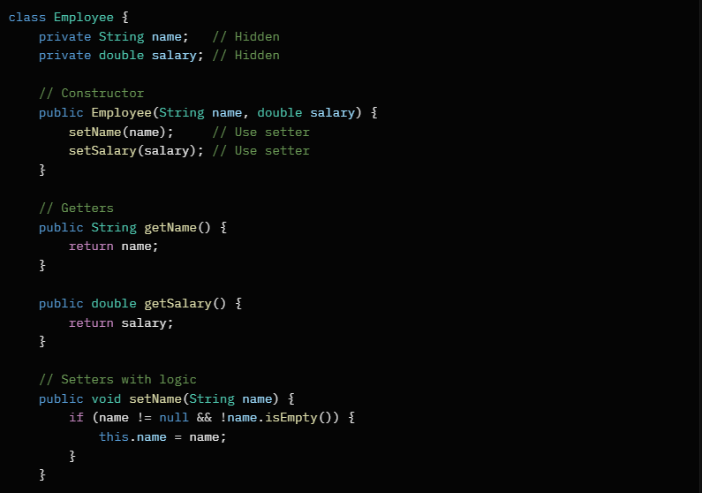
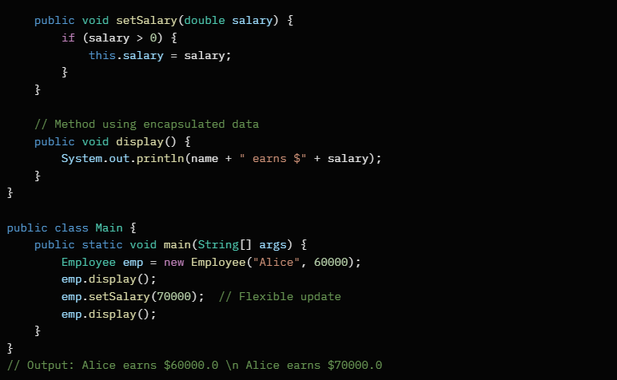
For interviews: Emphasize "Why private fields? (Hides implementation—change from double to BigDecimal without client updates.)" Common Q: "Can getters/setters be private? (Yes, for internal use.)" Discuss immutability (no setters) for thread-safety.
Access modifiers: public, private, protected, default

Access modifiers in Java are keywords that define the visibility or accessibility of classes, methods, variables, and constructors. They enforce encapsulation (hiding internal details) and promote good design by controlling who can access what. There are four main access modifiers: public, private, protected, and default (also called package-private, when no modifier is used). They apply differently to top-level classes (which can't be private or protected) versus members (fields, methods, constructors).
Key rule: Modifiers set a "permission level" – from widest (public) to narrowest (private). If something isn't accessible, you'll get a compilation error like "X has private access in Y."

1. Public Access Modifier
Definition: The most permissive level. A public member is accessible from anywhere – same class, same package, subclasses in other packages, or even unrelated classes in other packages.
Scope:
- Visible to all classes in the project (and beyond if in a library).
- Often used for APIs, getters/setters, or entry points like main() method.
When to Use: Expose functionality intentionally, like public methods in a class users interact with. Avoid overusing on fields to prevent direct manipulation.
Example: Consider a BankAccount class where the balance is private (hidden), but you provide a public method to check it.
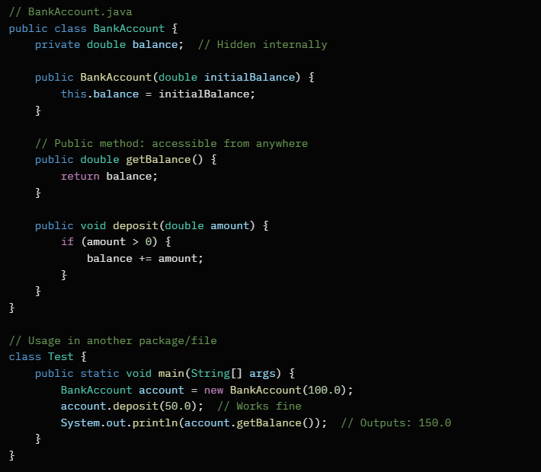

Here, getBalance() can be called from any class, even in a different package, promoting safe external access without exposing balance directly.

2. Private Access Modifier
Definition: The strictest level. A private member is accessible only within the same class. Nothing outside – not subclasses, not other classes in the same package – can touch it.
Scope:
- Limited to the class's own methods and constructors.
- Ideal for internal state that shouldn't be inherited or peeked at.
When to Use: Hide implementation details like helper variables or sensitive data. Forces use of public methods for interaction, upholding encapsulation.
Example: In the same BankAccount class, the balance field is private, so only class methods can modify it. This prevents external code from doing account.balance = -999; (which would break invariants).
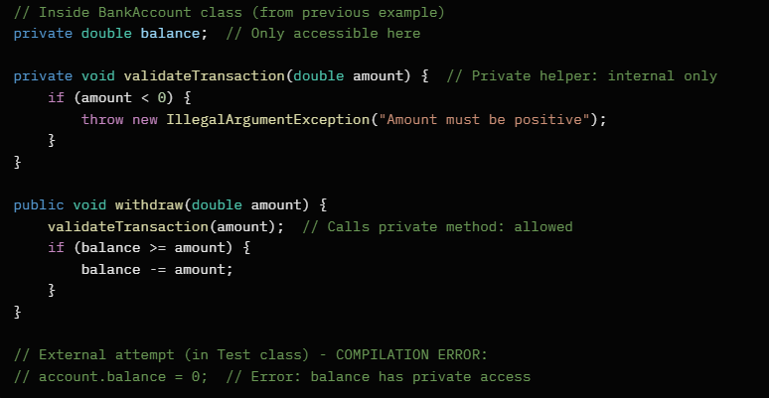

The private validateTransaction() ensures withdrawals are safe without exposing the logic.

3. Protected Access Modifier
Definition: A middle ground. A protected member is accessible within the same package (like default) and in subclasses (even if the subclass is in a different package). It's for inheritance-friendly access.
Scope:
- Same package: All classes.
- Different package: Only subclasses (via inheritance).
- Not for unrelated classes outside the package.
When to Use: Share behavior with child classes without making it fully public. Common in frameworks where base classes provide hooks for extension.
Example: Imagine a base Vehicle class with a protected method for subclasses to override or use, but not for random classes.
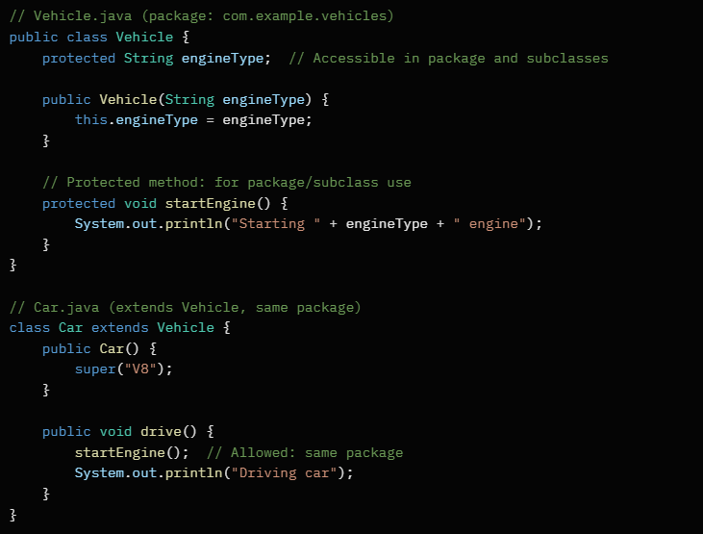
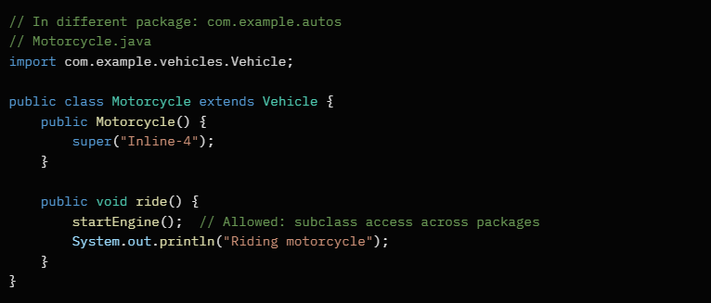
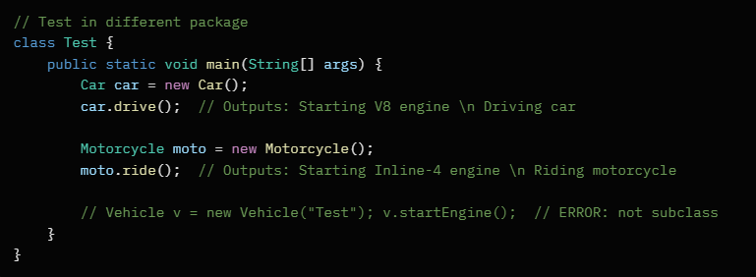

startEngine() is callable in Car (same package) and Motorcycle (subclass), but not in Test (unrelated class).

4. Default (Package-Private) Access Modifier
Definition: No keyword needed – just omit the modifier. Accessible only within the same package. Subclasses in other packages can't access it, unlike protected.
Scope:
- Limited to classes in the same directory/package.
- Behaves like "internal" to the module.
When to Use: For utilities or helpers shared among closely related classes in one package, without exposing to the world or inheritance.
Example: A utility class inside a package for internal sorting, visible only to other package classes.
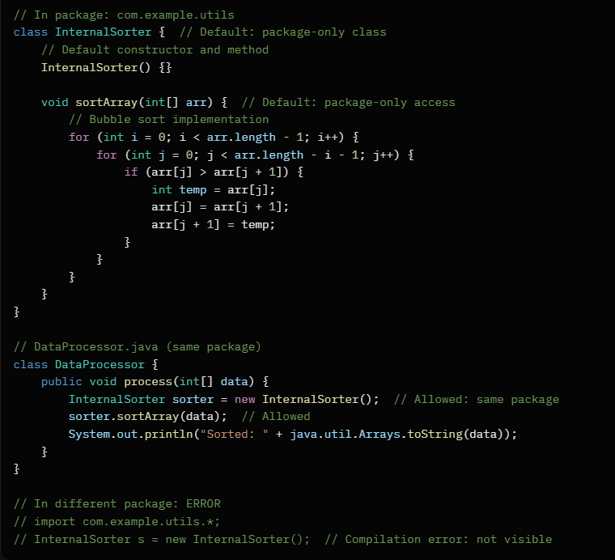
InternalSorter helps DataProcessor but stays hidden from external packages.

Comparison Table
Modifier | Same Class | Same Package (Non-Subclass) | Subclass (Same Package) | Subclass (Different Package) | Unrelated Class (Different Package)
Public | ✅ | ✅ | ✅ | ✅ | ✅
Protected | ✅ | ✅ | ✅ | ✅ | ❌
Default | ✅ | ✅ | ✅ | ❌ | ❌
Private | ✅ | ❌ | ❌ | ❌ | ❌

Interview Tips
- Common Question: "What's the difference between protected and default?" Answer: Protected adds cross-package subclass access; default doesn't.
- Pitfall: Forgetting that top-level classes are public or default only (not private/protected).
- Best Practice: Start with private for fields, public for methods, protected for overridable inheritance hooks, default for package internals.
- Why They Matter: They prevent tight coupling and accidental misuse, key for scalable code.
This covers the essentials without fluff – practice coding these scopes to nail interviews!

Associations: Aggregation (has-a), composition (part-of), and differences

In object-oriented programming (OOP), associations describe how classes relate to each other beyond inheritance (is-a). The two key types are aggregation (has-a relationship) and composition (part-of relationship). Both represent "whole-part" scenarios but differ in lifecycle dependency and ownership. They're visualized in UML with diamond arrows: empty diamond for aggregation, filled for composition.
These promote modularity – aggregation for loose coupling (reusable parts), composition for tight integration (parts belong exclusively to the whole). Misusing them can lead to memory leaks or inflexible code.

Aggregation (Has-A Relationship)
Definition: A "has-a" association where the whole (container) contains parts (components), but parts can exist independently. The lifecycle of the part isn't tied to the whole – if the whole is destroyed, parts survive. It's a weak, unidirectional ownership.
Scope:
- Parts can be shared across multiple wholes.
- Reference-based: Whole holds a reference to part (e.g., via pointer or object reference).
- Supports flexibility: Easy to swap or reuse parts.
When to Use: Model scenarios like libraries (books belong to library but can move elsewhere) or teams (employees in a department but can join another).
Example: A University (whole) has Students (parts). Students exist before/after the university (in real terms) and can transfer.

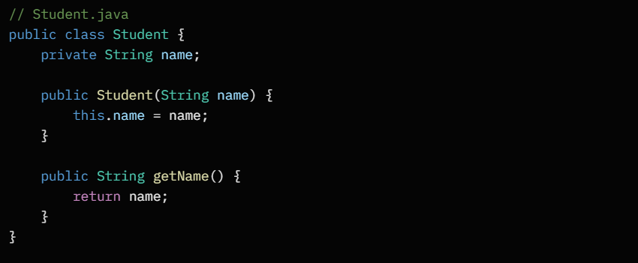
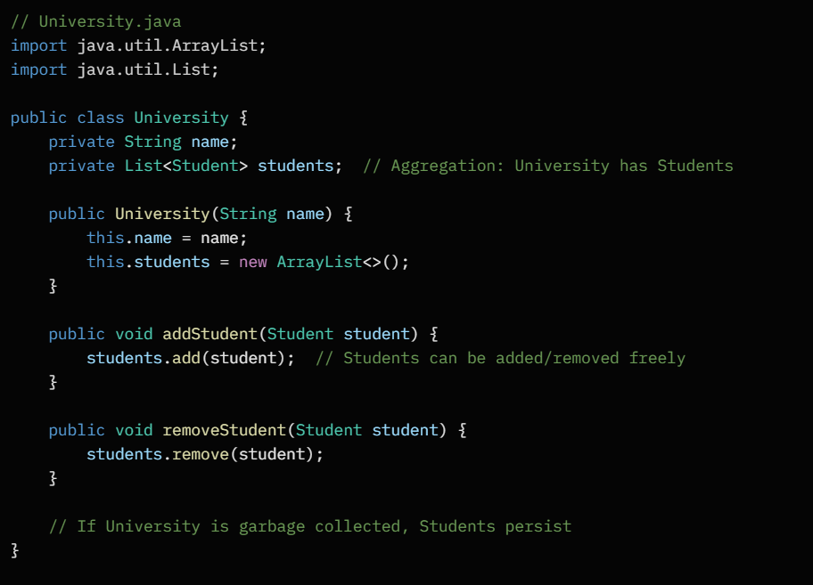
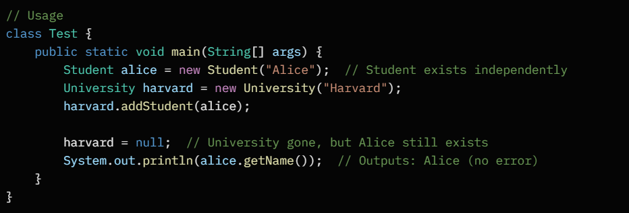
Here, Student objects can be created standalone and shared (e.g., transfer to another University).

Composition (Part-Of Relationship)
Definition: A stronger "part-of" association where the whole owns the parts exclusively, and parts' lifecycle is bound to the whole. If the whole is destroyed, parts are too (automatic cleanup). It's bidirectional in ownership but unidirectional in navigation.
Scope:
- Parts can't exist without the whole; no sharing.
- Containment-based: Whole creates and manages parts' lifecycle.
- Ensures integrity: Prevents orphaned parts.
When to Use: Model inseparable units like houses (rooms can't exist alone) or cars (engine is integral).
Example: A Car (whole) is composed of an Engine (part). The engine is created with the car and destroyed when the car is.
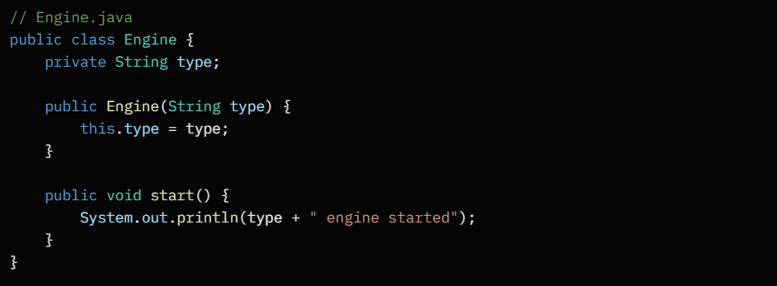
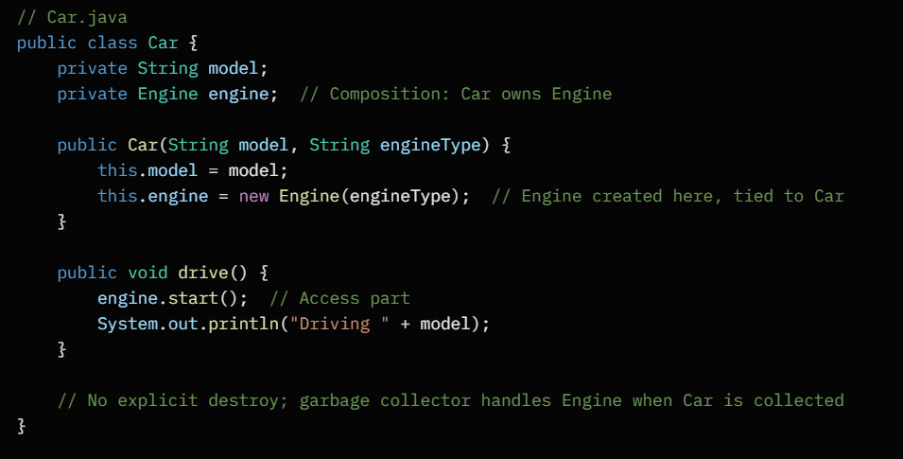
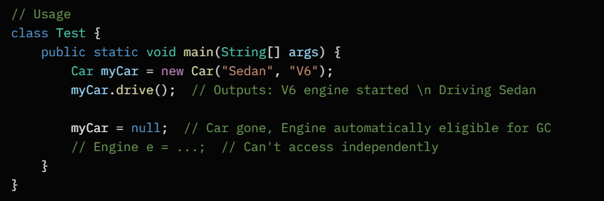

The Engine is instantiated inside Car's constructor, ensuring it's part of the car forever.

Key Differences
Aspect | Aggregation (Has-A) | Composition (Part-Of)
Ownership | Weak: Whole references part | Strong: Whole owns and creates part
Lifecycle | Independent: Part survives whole | Dependent: Part dies with whole
Sharing | Allowed: Part usable by multiple wholes | Not allowed: Exclusive to one whole
UML Notation | Empty diamond on whole side | Filled diamond on whole side
Flexibility | High: Easy add/remove/swap | Low: Rigid structure
Example Analogy | Library has books (books movable) | House has rooms (rooms fixed)
Memory Mgmt | Manual: Handle part cleanup | Automatic: Tied to whole's GC

Interview Tips
- Common Question: "Aggregation vs. Composition?" Answer: Both are has-a, but composition implies stronger dependency (lifecycle-bound, no sharing).
- Pitfall: Don't confuse with inheritance – use aggregation/composition to avoid "is-a" misuse (e.g., Car has Engine, not is-an Engine).
- Best Practice: Favor composition over inheritance for flexibility ("composition over inheritance"). In Java, use collections for aggregation, inner objects for composition.
- Extension: In UML, multiplicity (e.g., 1..*) shows cardinality, like one university to many students.

Keywords like this (for current instance) and super (for parent class)

Introduction to 'this' and 'super' Keywords in Java
In Java, this and super are special reference keywords that help navigate object relationships within inheritance hierarchies. They resolve ambiguities and enable clean access to class members. this points to the current object (self-reference), while super points to the parent class (up the inheritance chain). Both can't be used in static contexts (e.g., static methods) since they require an instance.
They're crucial for polymorphism, constructor chaining, and overriding – misuse leads to compilation errors like "non-static variable cannot be referenced from static context."

'this' Keyword: Referencing the Current Instance
Definition: “this” refers to the current object of the class. It's implicitly available in instance methods/constructors and helps disambiguate when local variables/parameters shadow instance fields (same name).
Scope and Uses:
- Disambiguate fields: this.fieldName vs. parameter fieldName.
- Constructor chaining: this(args) to call another constructor in the same class (must be first statement).
- Pass current object: As argument to methods (e.g., for callbacks).
- Return current object: For method chaining (fluent interfaces).
- Not usable in static methods; can't be assigned (it's a reference, not a variable).
When to Use: Whenever you need to refer to the instance explicitly, especially in setters or chained constructors to avoid confusion.
Example: A Person class with a setter that uses this to update the instance field, and constructor chaining for reuse.
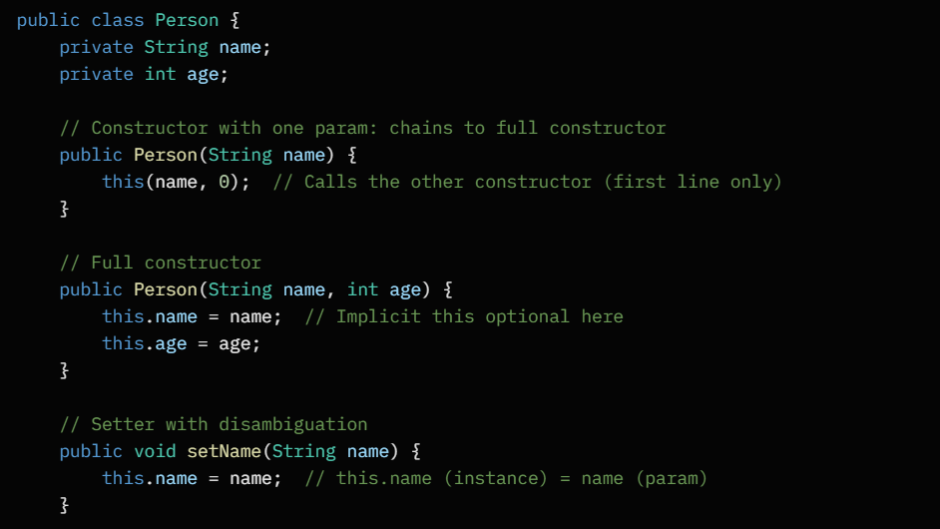
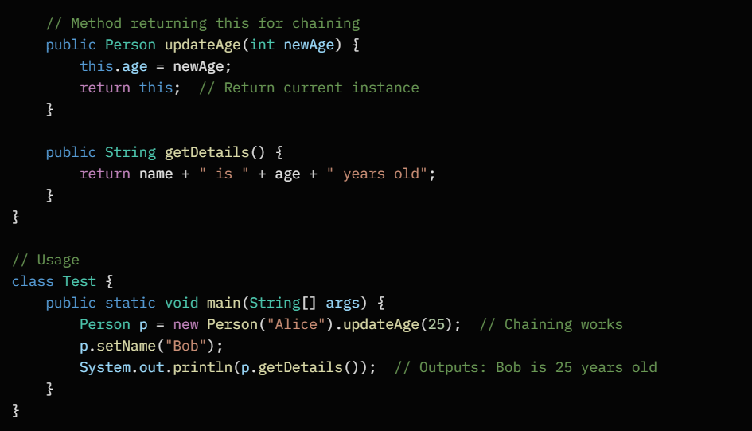
Here, this(name, 0) reuses logic; this.name = name avoids shadowing; return this enables fluent calls.

'super' keyword: Referencing the Parent Class
Definition: super refers to the immediate superclass (parent). It allows access to overridden/hidden members and ensures parent initialization.
Scope and Uses:
- Constructor chaining: super(args) to call parent constructor (must be first statement if used).
- Access parent members: super.method() or super.field when overridden/shadowed in child.
- Only one level up (not grandparent directly; chain via parent's super).
- Implicit call to super() in child constructors if omitted (no-args parent constructor).
When to Use: In subclasses to invoke parent behavior, especially for partial overriding or mandatory parent setup.
Example: Extend Person to Employee, using super to call parent constructor and access hidden method.
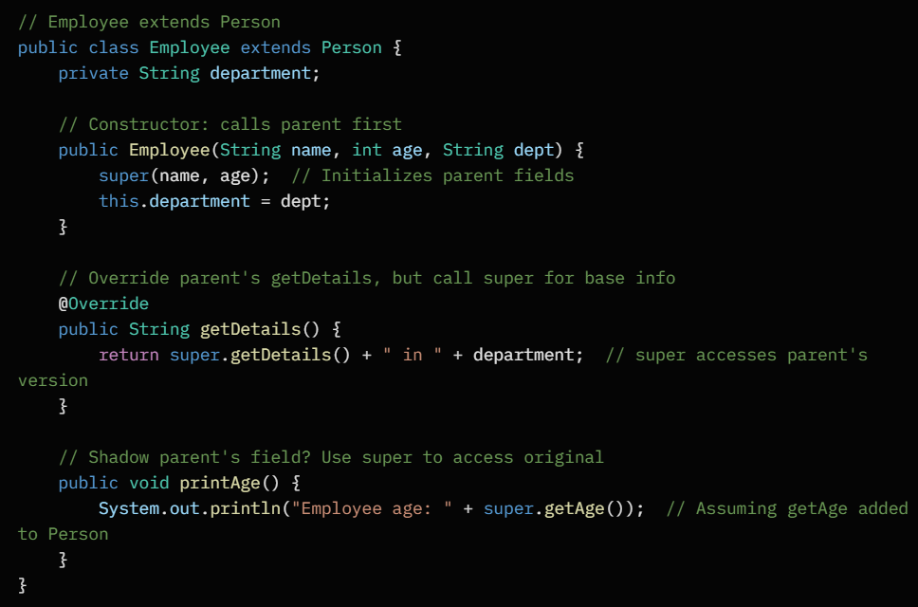
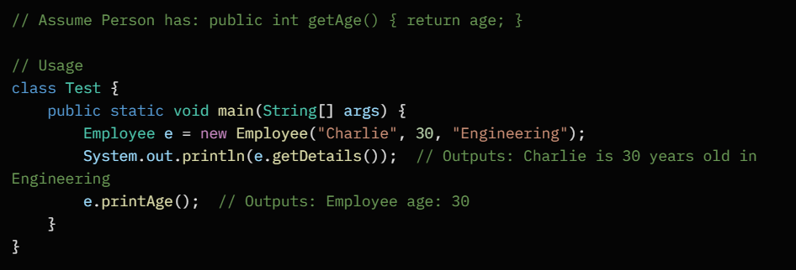
super(name, age) sets up the parent; super.getDetails() appends without losing base functionality.

Key Differences
Aspect | 'this' (Current Instance) | 'super' (Parent Class)
Refers To | Current object | Immediate superclass
Primary Uses | Disambiguate fields, chain constructors, return self | Call parent constructor/method/field
Context | Instance methods/constructors | Subclass instance methods/constructors
Static Usable? | No | No
Chaining | Same class constructors | Parent constructors
Overriding | N/A (self-focused) | Access hidden parent members
Example Analogy | "Me" in a conversation | "My parent" in family tree

Interview Tips
- Common Question: "When must super() be first in constructor?" Answer: Always if explicit; implicit otherwise. Can't follow this().
- Pitfall: Forgetting super() in child with no-arg parent leads to error if parent lacks default constructor.
- Best Practice: Use this for intra-class, super for inter-class; combine in overrides like super.method() + childLogic.
- Trick Question: Can this call super? Yes, indirectly via constructors.
Practice inheritance chains – code a multi-level hierarchy to see flows!

Object cloning, equals() and hashCode() methods, and toString()

Introduction to Object Cloning, equals(), hashCode(), and toString() in Java
These are core methods from java.lang.Object (the root of all classes) that enable customization of object behavior. Cloning creates copies; equals() checks logical equality; hashCode() supports hashing (e.g., for Sets/Maps); toString() provides readable string reps. Overriding them ensures correct behavior in collections, debugging, and comparisons. Always override them together when needed – e.g., equals() and hashCode() must align per contract.

Object Cloning
Definition: Cloning creates a shallow copy of an object (duplicates fields' references, not deep copies of objects inside). Java's Object.clone() is protected and shallow by default; to use it, implement Cloneable marker interface and override clone() to public/throw CloneNotSupportedException.
Scope:
- Shallow: Copies primitives and references; nested objects share state (use deep clone for full independence).
- Throws CloneNotSupportedException if not Cloneable.
- Not for final fields or singletons (immutable design).
When to Use: Duplicate mutable objects without altering originals, like in prototypes or undo features. Prefer copy constructors for simplicity over cloning.
Example: A Point class with x/y coords. Shallow clone copies coords; deep would clone nested if any.
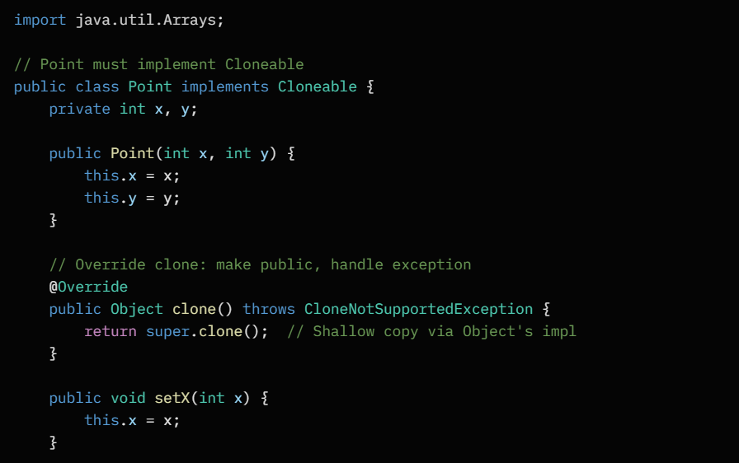
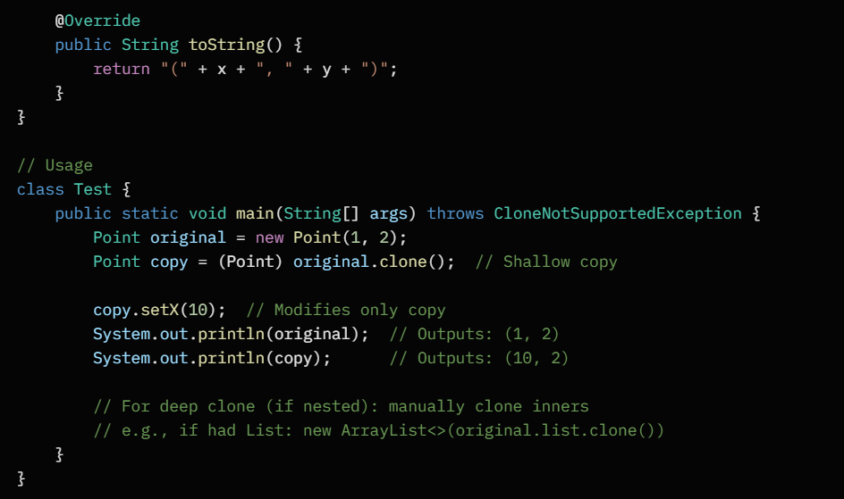
Cloning here creates an independent Point; changes to copy don't affect original. For deep, override to clone nested structures.

equals() Method
Definition: Checks if two objects are "logically equal" (same state), not identity (==). Default Object.equals() uses == (reference equality). Override for value-based comparison (e.g., same fields).
Scope:
- Reflexive, symmetric, transitive, consistent, handles null.
- Use instanceof or getClass() for type check; compare all relevant fields.
- Primitives: ==; objects: recurse or use Objects.equals().
When to Use: In collections (e.g., Set.contains()) or custom comparisons. Always pair with hashCode().
Example: Override in Point to compare co-ords, ignoring reference.
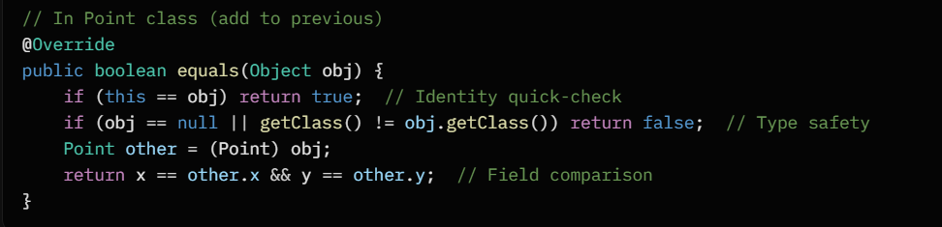
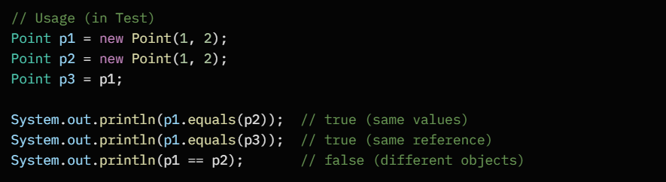
equals() returns true for logically same points, even if separate instances.

hashCode() Method
Definition: Returns an int hash for the object, used in hash-based collections (HashMap, HashSet). Default is identity-based; override for consistent value-based hashing.
Scope:
- Contract: If a.equals(b), then a.hashCode() == b.hashCode() (but not vice versa – collisions ok).
- Consistent: Same state yields same hash across calls.
- Good distribution: Use prime multipliers (e.g., 31) to minimize collisions.
- Formula: Often field1.hashCode() * 31 + field2.hashCode() + ....
When to Use: Whenever overriding equals(), to ensure collections work correctly (e.g., no duplicates in Set).
Example: Override in Point using co-ords for hash.
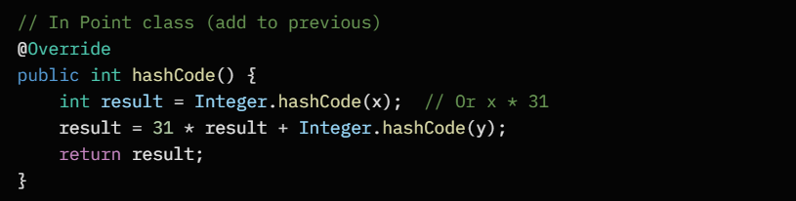
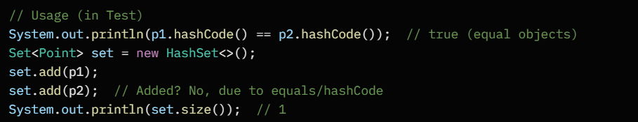
Matching hashes ensure p2 is treated as duplicate in HashSet.

toString() Method
Definition: Returns a string representation of the object for readable output. Default is Class@hashCode (unhelpful); override for meaningful info like field values.
Scope:
- Called implicitly by System.out.println(obj) or string concatenation.
- Include class name and key fields; avoid sensitive data.
- No-arg, returns String.
When to Use: Debugging, logging, or displaying objects. Makes code more maintainable.
Example: Already in the Point example above: return "(" + x + ", " + y + ")";
Without override: Point@1b6d3586 (useless).

Key Relations and Differences
Method | Purpose | Override When | Contract/Notes
clone() | Create object copy | Implementing mutable objects | Shallow by default; handle exceptions
equals() | Logical equality check | Value-based comparison needed | Symmetric/transitive; pair w/ hashCode
hashCode() | Hash value for collections | Overriding equals() | Consistent w/ equals; good distribution
toString() | Readable string rep | Human-readable output wanted | Called by println; simple format
- equals() & hashCode() Link: Violating contract causes bugs in Maps/Sets (e.g., can't find equal objects).
- Cloning vs. Others: Independent; cloning uses equals() for deep checks if needed.

Interview Tips
- Common Question: "Why override hashCode with equals?" Answer: Hash-based structures rely on both; mismatch leads to lost elements.
- Pitfall: Forgetting null-safety in equals (use Objects.equals() helper) or mutable fields in hashCode (recompute on change).
- Best Practice: Use IDE auto-generate; for cloning, consider CopyOnWrite or builders over raw clone.
- Trick: String overrides all: equals checks content, hashCode is cached, toString is itself.
Code these in a hierarchy – test in collections to solidify!

Marker interfaces and their role in providing runtime information

Introduction to Marker Interfaces in Java
Marker interfaces (also called tag interfaces) are empty interfaces – they declare no methods, fields, or constants. They serve as a "flag" or label attached to a class via implements. Their power lies not in code enforcement (like regular interfaces) but in runtime introspection: the JVM, libraries, or code can check for their presence using instanceof to alter behavior dynamically. This enables polymorphism without boilerplate and supports framework decisions (e.g., serialization).
Unlike regular interfaces (e.g., Runnable with run()), markers don't require implementation logic – just adoption. They're lightweight but crucial for Java's extensibility. Misusing them (e.g., over-tagging) can confuse readers, so use sparingly.

Definition and Characteristics
Definition: A marker interface is an interface with zero abstract methods. A class implements it to signal a capability, which runtime code detects.

Key Traits:
- Empty: No methods to implement (compiles trivially).
- Runtime Detection: Checked via instanceof MyMarker.class – true if implemented.
- No Compile-Time Enforcement: Doesn't force behavior; relies on conventions/libraries.
- Inheritance: Subclasses inherit the marker (e.g., if Parent implements it, Child does too unless suppressed).
- Annotations Alternative: Modern Java favors @Target annotations (e.g., @Deprecated) over markers for metadata, but markers persist in core APIs.
When to Use: Tag classes for special treatment, like optimization hints or serialization hooks. Avoid for new code – prefer annotations for clarity.

Role in Providing Runtime Information
Markers act as metadata providers at runtime, allowing:
- Capability Signaling: Libraries query instanceof to enable features (e.g., auto-serialization).
- Optimization Cues: JVM or code branches based on presence (e.g., faster access patterns).
- Behavioral Hooks: Without methods, they trigger predefined logic in frameworks (e.g., reflection-based processing).
- Loose Coupling: Classes don't need to know internals; just implement the tag.
This is "runtime information" because it's checked dynamically (via reflection or instanceof), not at compile-time. It promotes design by contract without tight coupling.
Example Scenario: In collections, RandomAccess marks lists with efficient random access, letting APIs choose iteration strategies at runtime.

Examples of Built-in Marker Interfaces
1. Serializable (java.io.Serializable)
Role: Tags classes for automatic object serialization (converting to byte stream for storage/transmission). Runtime: ObjectOutputStream checks instanceof Serializable before serializing; non-compliant classes throw NotSerializableException.
Runtime Info Provided: Indicates the object can be safely flattened/reconstructed, preserving state across JVMs.
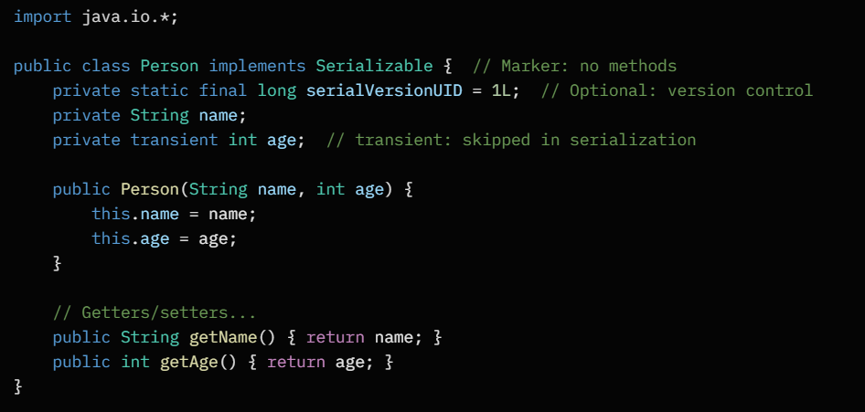
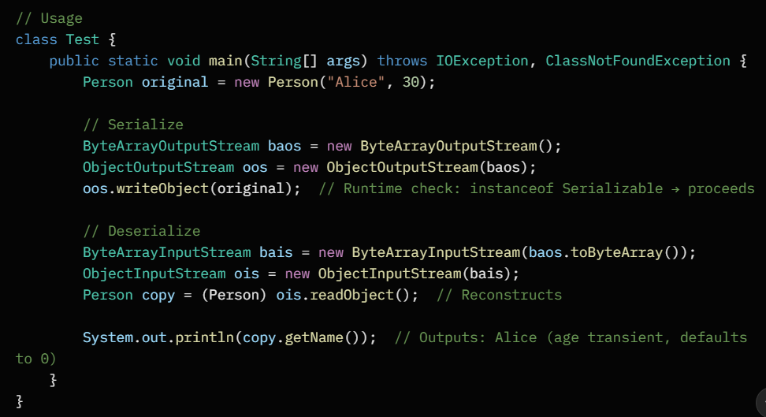
Without implements Serializable, serialization fails at runtime. It provides info for deep cloning or persistence.

2. Cloneable (java.lang.Cloneable)
Role: Permits Object.clone() usage. Runtime: If not implemented, clone() throws CloneNotSupportedException.
Runtime Info Provided: Signals the class supports shallow copying, allowing generic duplicators.
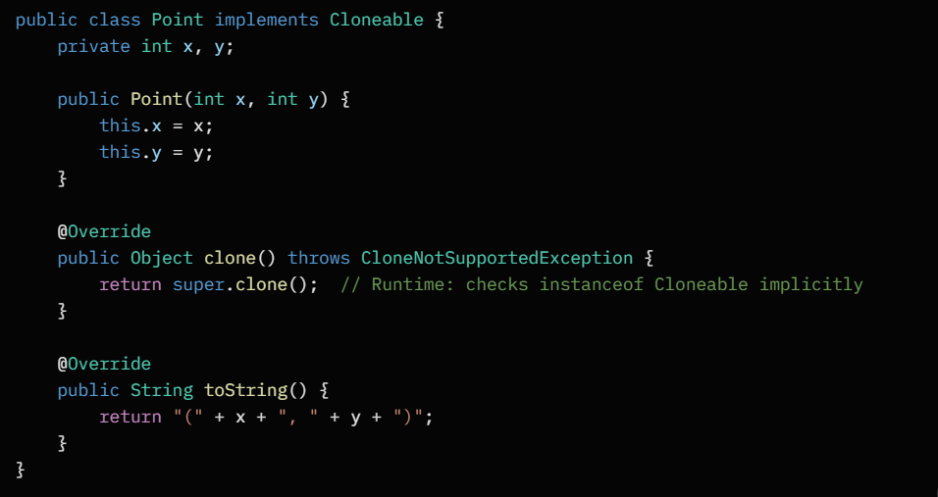
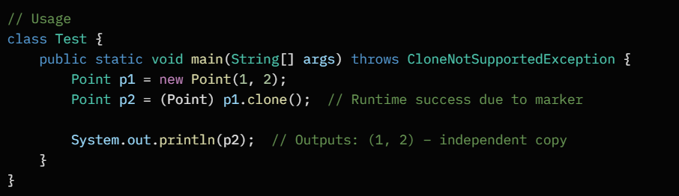
The marker informs clone() it's safe to proceed, enabling runtime copying without per-class checks.

3. RandomAccess (java.util.RandomAccess)
Role: Hints that a List implementation supports O(1) random access (e.g., ArrayList vs. LinkedList's O(n)).
Runtime Info Provided: Allows APIs (like Collections.sort()) to pick efficient algorithms dynamically.
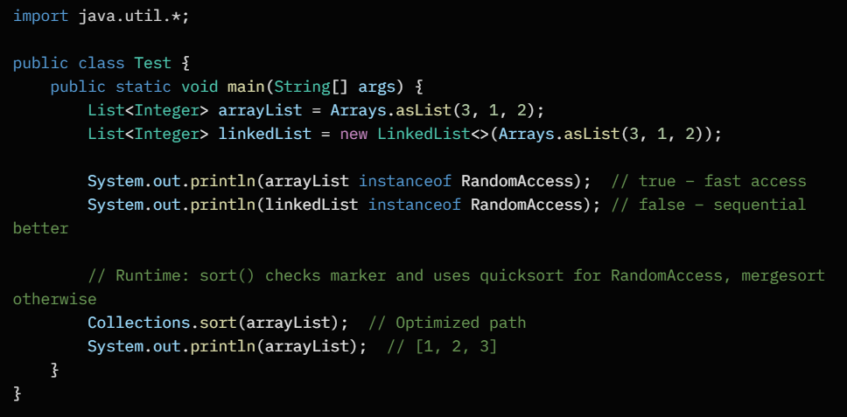
It provides performance metadata, letting the runtime choose without hardcoding class types.

Custom Marker Interface Example
Create one for "thread-safe" tagging, checked at runtime for locking decisions.
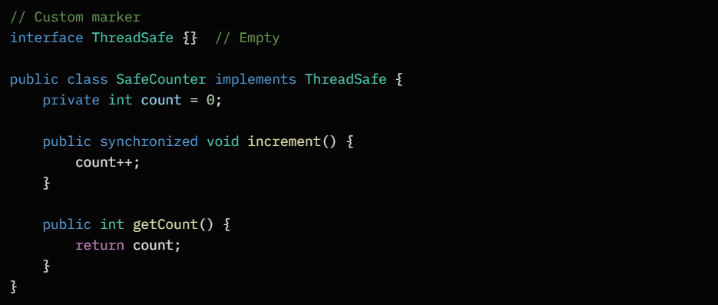
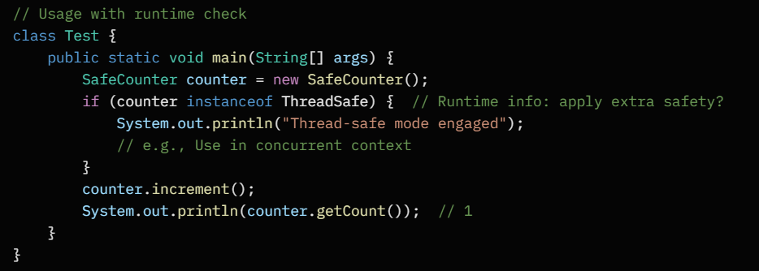
Here, the marker flags the class for special handling, like in a utility library.
Comparison Table: Marker vs. Regular Interfaces
Aspect | Marker Interface | Regular Interface
Methods | None (empty) | One or more abstract methods
Implementation | Trivial (no code needed) | Requires method bodies
Purpose | Runtime tagging/metadata | Enforce contract/behavior
Detection | instanceof at runtime | Compile-time + runtime polymorphism
Examples | Serializable, Cloneable | Runnable, Comparable
Modern Alt | Rarely used; prefer annotations | Still core for APIs

Interview Tips
- Common Question: "Why use Serializable as a marker?" Answer: It signals to the JVM/libraries that the class can be serialized; runtime checks prevent errors without method enforcement.
- Pitfall: Markers don't guarantee behavior – e.g., implementing Serializable doesn't auto-handle cycles; you manage serialVersionUID.
- Best Practice: For new markers, use @interface annotations (e.g., @Safe) with reflection – more flexible than class-level tags.
- Trick: Remote (RMI) is another marker for distributed objects, checked at runtime for proxying.
These enable Java's "pay-for-what-you-use" model – implement once, unlock runtime magic! Practice by implementing Serializable in a graph class to see deep serialization.

Composition vs. aggregation, and inner classes (static, non-static, anonymous)

Composition vs. Aggregation in Java
In OOP, both composition and aggregation model "has-a" relationships between classes, representing whole-part structures. They differ in ownership strength and lifecycle dependency: composition is a strong form (parts are integral, can't survive without the whole), while aggregation is weak (parts are independent, can be reused). Use composition for exclusive ownership (e.g., body parts of a person); aggregation for shared associations (e.g., students in a class). Both leverage references but avoid inheritance pitfalls.

Composition: Strong Ownership (Part-Of)
Definition: The whole owns and manages the part's entire lifecycle – parts are created/destroyed with the whole, can't be shared.
Key Traits:
- Exclusive: One part per whole (or multiples, but not shared).
- Tighter coupling: Enhances encapsulation but reduces flexibility.
- UML: Filled diamond on whole side.
Example: A House composed of Rooms – rooms don't exist without the house.
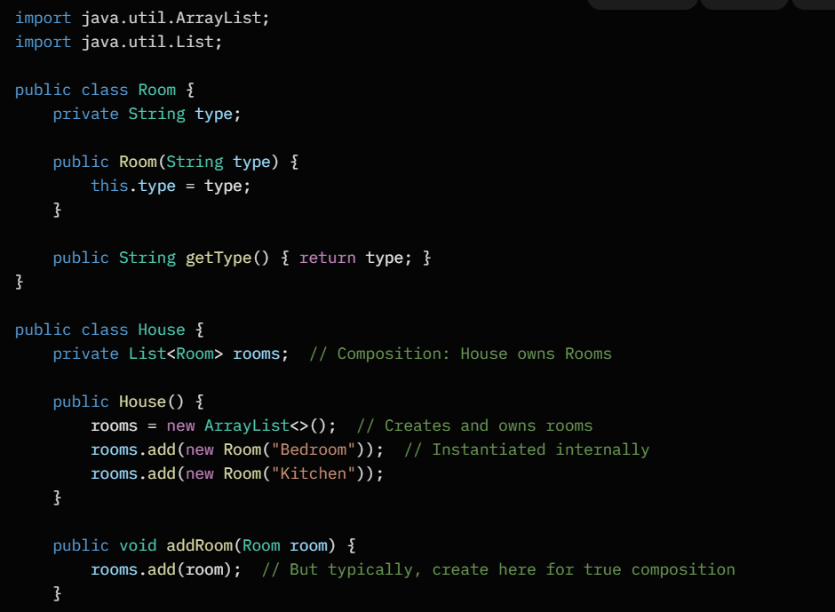
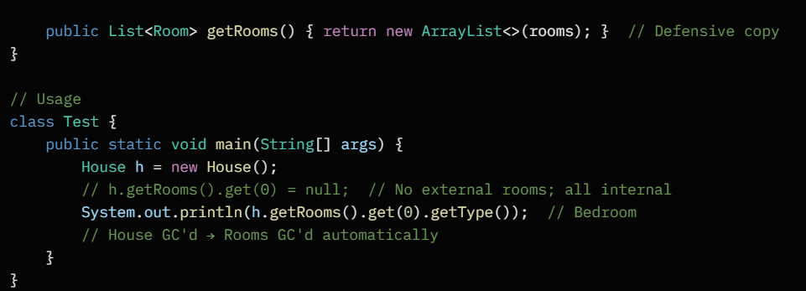
Rooms are born and die with House; no external reference to them.

Aggregation: Weak Ownership (Has-A)
Definition: The whole references the part, but parts have independent lifecycles – whole can exist without parts, and vice versa; sharing allowed.
Key Traits:
- Non-exclusive: Parts can belong to multiple wholes.
- Looser coupling: Easier to reconfigure.
- UML: Empty diamond on whole side.
Example: A Department aggregates Employees – employees can switch departments or exist solo.
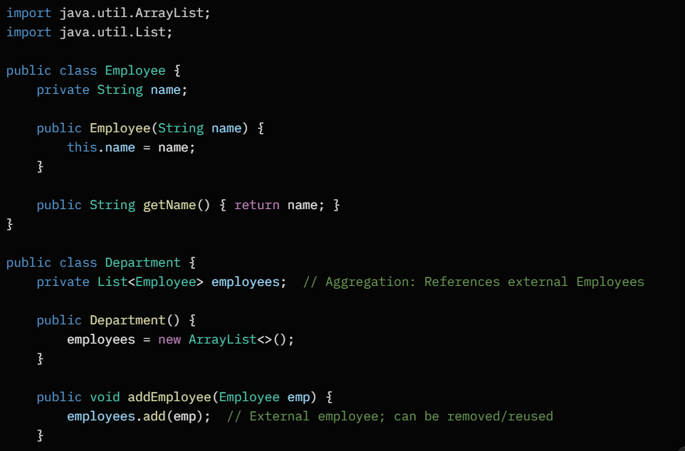
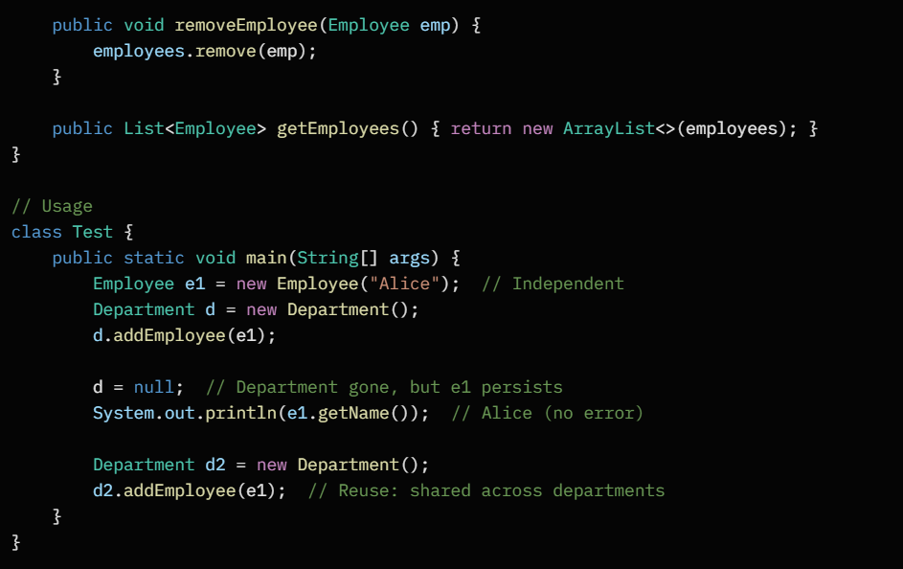
Employee outlives Department; easy to transfer.

Differences Table
Aspect | Composition (Strong) | Aggregation (Weak)
Lifecycle | Part dies with whole | Part independent of whole
Ownership | Whole creates/manages part | Whole references external part
Sharing | No (exclusive) | Yes (reusable)
Coupling | Tight (inflexible) | Loose (flexible)
Deletion | Automatic (GC handles) | Manual (part survives)
Real-World | Car-Engine | Team-Player

Inner Classes in Java
Inner classes are classes defined inside another class, promoting encapsulation and logical grouping. They access outer class members implicitly. Types: non-static inner (instance-bound), static nested (class-bound), and anonymous (one-off implementations). All can be private/protected, unlike top-level classes. Use them to hide helpers or pass behaviors (e.g., listeners).

Non-Static Inner Class (Instance-Bound)
Definition: Tied to an outer instance – needs outer object to exist; has implicit this reference to outer.
Key Traits:
- Access: Can use outer's private members; outer can't access inner directly.
- Creation: new Outer().new Inner().
- Memory: Separate object, but holds outer reference (potential leak risk).
When to Use: When inner needs outer state (e.g., event handlers).
Example: Outer with Inner that accesses outer's field.
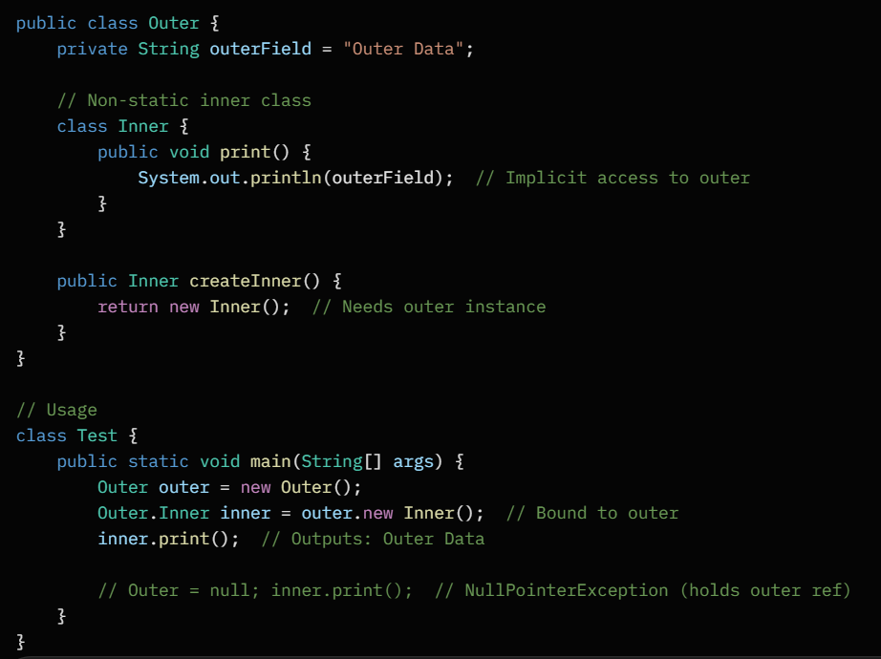Inner "sees" outerField without qualifiers.

Static Nested Class (Class-Bound)
Definition: Static member class – no tie to outer instance; like a top-level class but namespaced.
Key Traits:
- Access: Can't use outer's non-static members (needs instance).
- Creation: new Outer.Nested().
- Memory: Independent; no outer reference.
When to Use: Utility classes grouped with outer (e.g., enums, builders).
Example: Outer with static Nested for a helper.
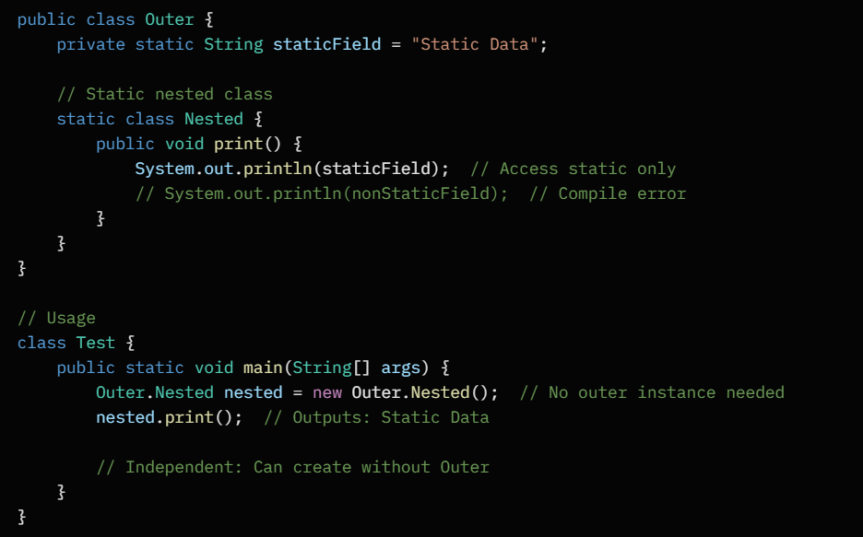Like a static method but for whole classes; no instance dependency.

Anonymous Inner Class (One-Off)
Definition: Nameless inner class for immediate use, often implementing interfaces/extending classes. Syntactic sugar for simple overrides.
Key Traits:
- Creation: Inline, e.g., new Interface() { ... }.
- Access: Captures outer variables (effectively final).
- Single-use: No reuse; compiles to private static inner class.
When to Use: Quick callbacks (e.g., comparators, listeners) – now often lambdas in Java 8+.
Example:
Without anonymous class
interface Greeting {
void sayHello();
}

class Hello implements Greeting {
public void sayHello() {
System.out.println("Hello World");
}
}

Using Anonymous Inner Class
interface Greeting {
void sayHello();
}

public class Test {
public static void main(String[] args) {

// Anonymous inner class implementing interface
Greeting g = new Greeting() {
@Override
public void sayHello() {
System.out.println("Hello World");
}
};

g.sayHello();
}
}

Key points
- No class name
- Created and used at the same time
- Used for one-time implementation
- Common with interfaces and abstract classes

Inner Classes Comparison Table
Type | Binding | Outer Access | Creation Syntax | Use Case
Non-Static | To outer instance | Full (instance + static) | outer.new Inner() | State-dependent helpers
Static Nested | To outer class | Static only | new Outer.Nested() | Independent utilities
Anonymous | To outer instance | Full (via capture) | new Type() { ... } | One-time implementations

Interview Tips
- Composition vs. Aggregation Q: "Give UML difference." Answer: Filled vs. empty diamond; stress lifecycle.
- Inner Classes Q: "Why non-static over static?" Answer: Needs outer instance for context.
- Pitfall: Anonymous classes can't be abstract or have constructors; watch for memory leaks in long-lived inners.
- Best Practice: Prefer lambdas over anonymous for functionals; static for pure utilities.

